әл-Фараби атындағы қазақ ұлттық университеті



Зертханалық жұмыс № 7

**Пән: Сетевые технологии**

**Тақырыбы: Wi-Fi**

Тексерген: Маликова Ф. У.

Орындаған: Якуфуцзян Азати

Тобы: ВТиПО

## Access Control List (ACL) configuratin on Cisco Packet Trace

Access Control List или ACL — список управления доступом, который определяет, кто или что может получать доступ к объекту (программе, процессу или файлу), и какие именно операции разрешено или запрещено субъекту (пользователю, группе пользователей).

The Standard Access List (ACL) on Cisco router works to permit or deny the entire network protocols of a host from being distinguishing. These decisions are all based on source IP address which filter network traffic by examining the source IP address in a packet.

1. Apply ACL (Access Control List) on the topology.

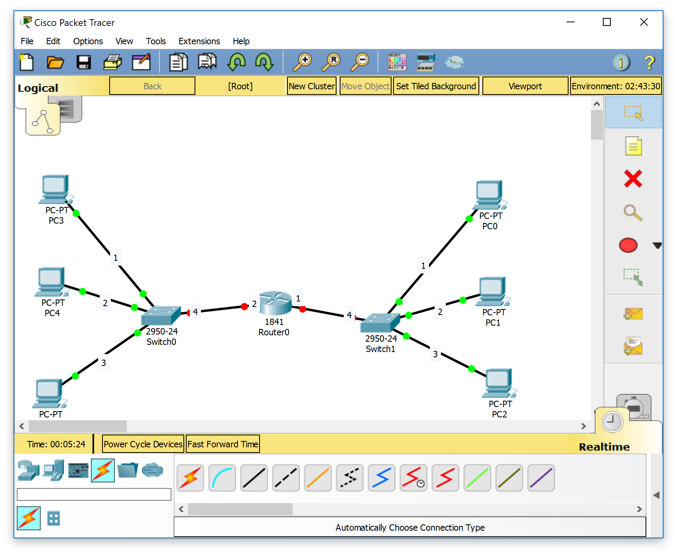

1. Link switch 1 with pc0,pc1,pc2 using straight line in port fa0/1 ,fa0/2,fa0/3

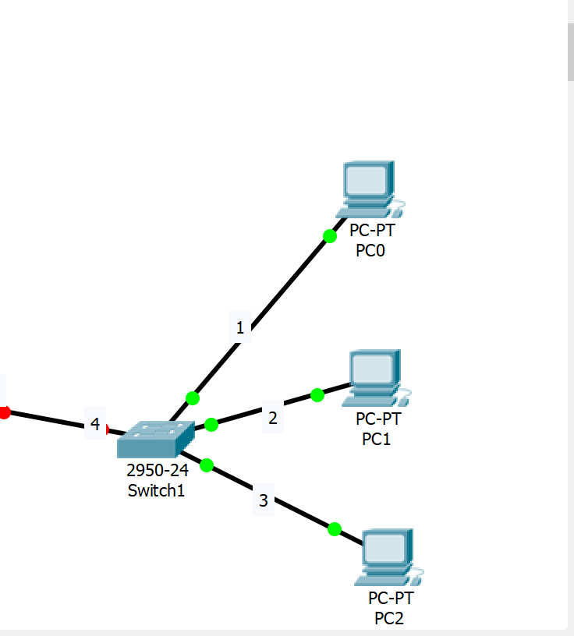

1. Link switch 2950-24 with Router 1841 using straight line in port fa0/4 –fa0/1

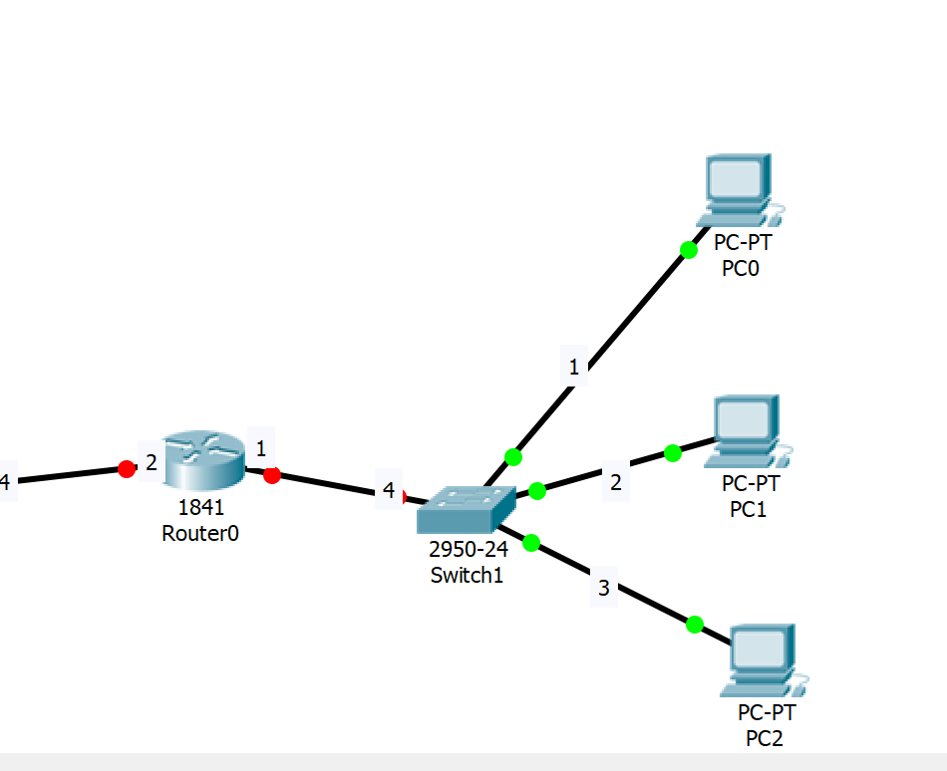

1. Link switch 0 with pc3,pc4,pc5 and router 0 using straight line in port :

Fa0/1,fa0/2,fa0/3,fa0/4 (fa0/4 with fa0/2 on router)

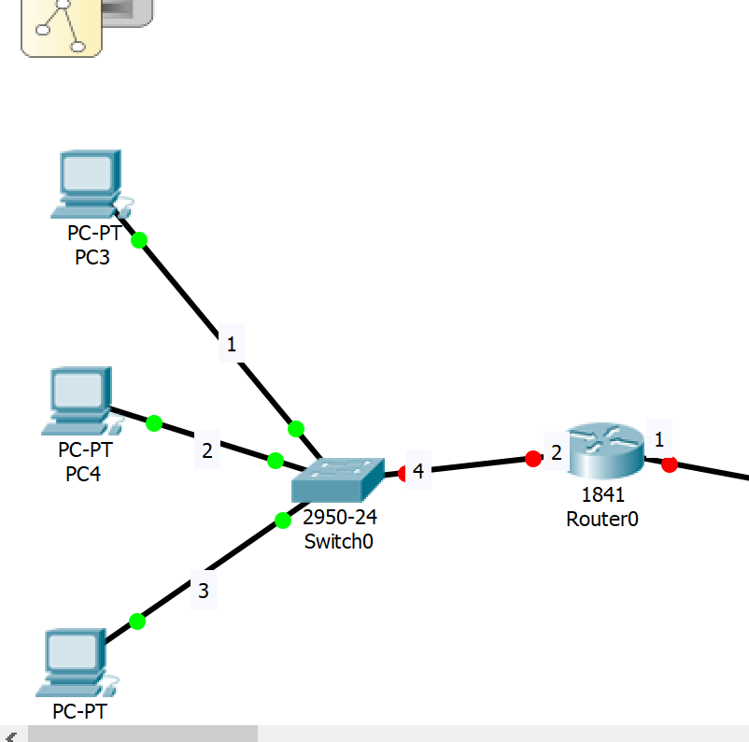

1. First, we have to assign IP addresses and change the state of the interfaces.

Router#configure terminal

Enter configuration commands, one per line. End with CNTL/Z.

Router(config)#interface fast0/0

Router(config-if)#no shutdown

Router(config-if)#

%LINK-5-CHANGED: Interface FastEthernet0/0, changed state to up

%LINEPROTO-5-UPDOWN: Line protocol on Interface FastEthernet0/0, changed state to up

Router(config-if)#ip address 192.168.1.1 255.255.255.0

Router(config-if)#

Router(config-if)#exit

Router(config)#int fa0/0

Router(config-if)#ip add 192.168.2.1 255.255.255.0

Router(config-if)#no shutdown

Router(config-if)#

Router#

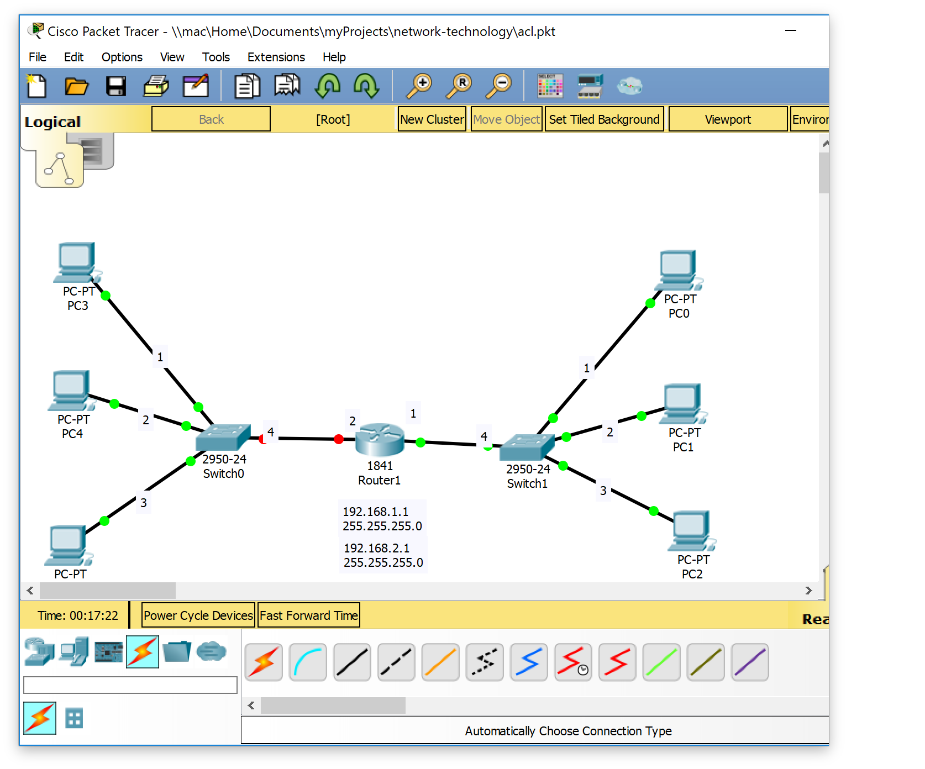

Router(config)#

Router(config)#int fa0/0

Router(config-if)#ip add 192.168.1.1 255.255.255.0

Router(config-if)#no shutdown

Router(config-if)#

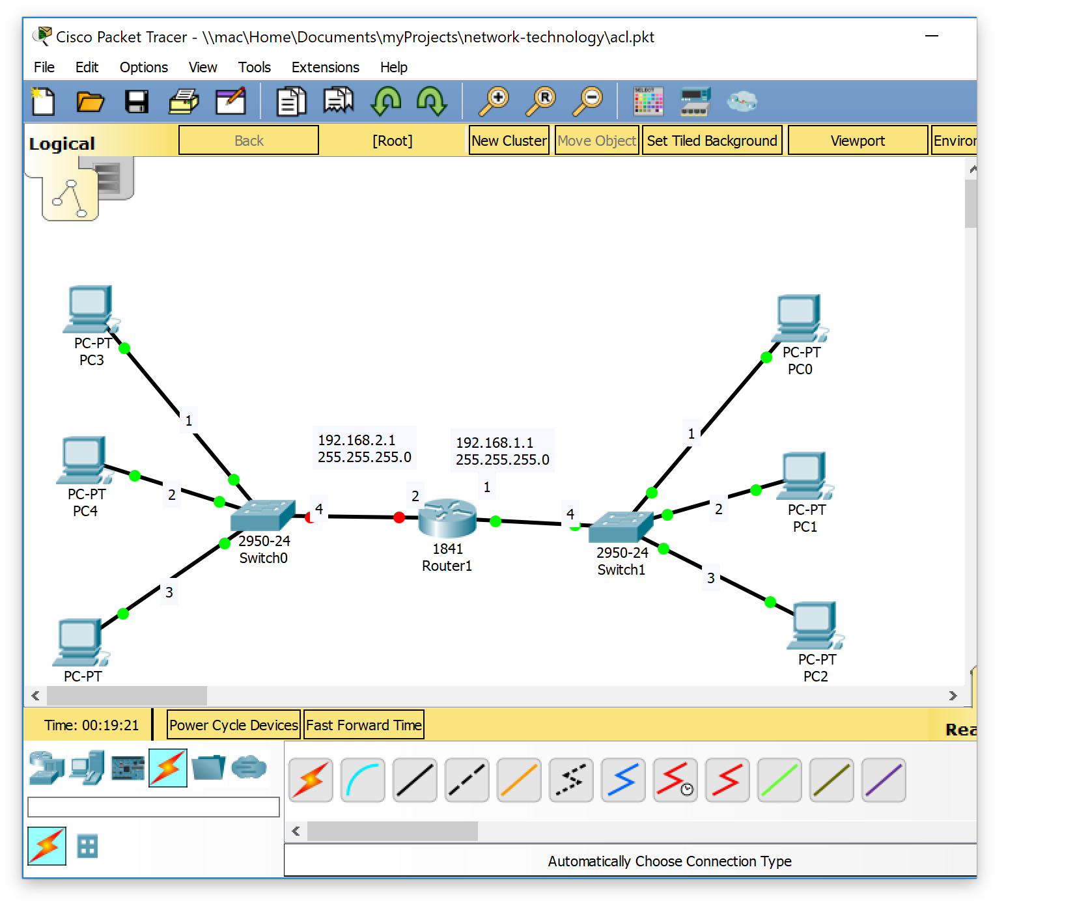

Router(config)#

Router(config)#

Router(config)#

Router(config)#int fa0/0

Router(config-if)#ip add 192.168.1.1 255.255.255.0

Router(config-if)#no shutdown

Router(config-if)#int fa0/1

Router(config-if)#ip add 192.168.2.1 255.255.255.0

Router(config-if)#no shutdown

Router(config-if)#

%LINK-5-CHANGED: Interface FastEthernet0/1, changed state to up

%LINEPROTO-5-UPDOWN: Line protocol on Interface FastEthernet0/1, changed state to up

Router(config-if)#

Router#

%SYS-5-CONFIG_I: Configured from console by console

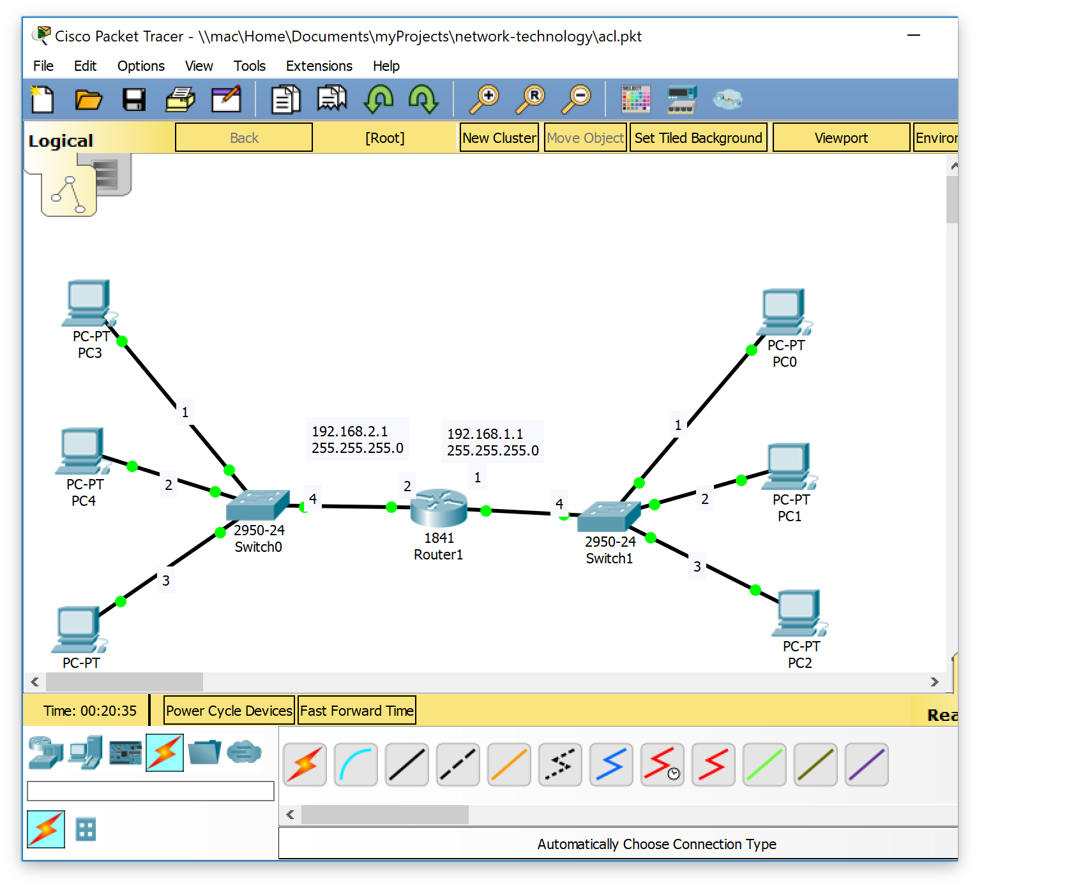

1. Here, the status is change as shown in the following diagram.

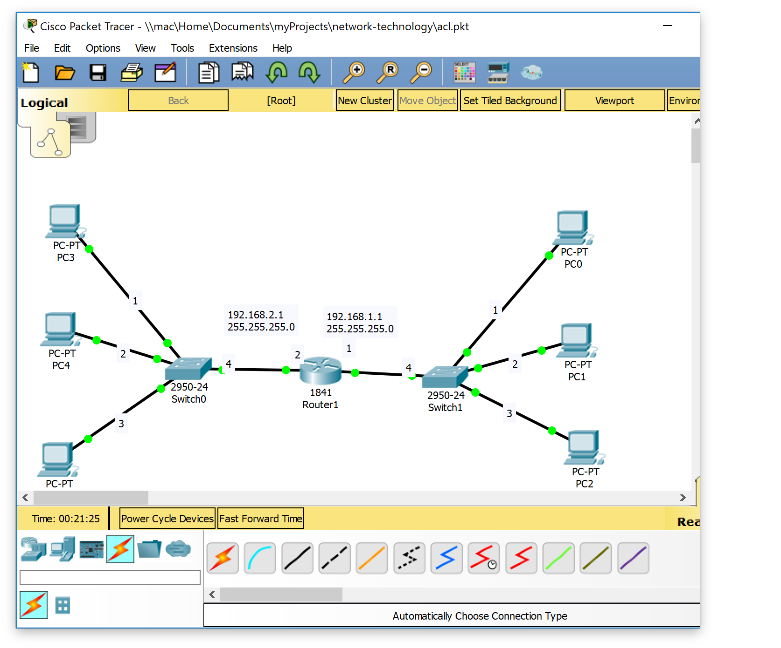

1. Then, we will have to assign IP addresses to the PCs.

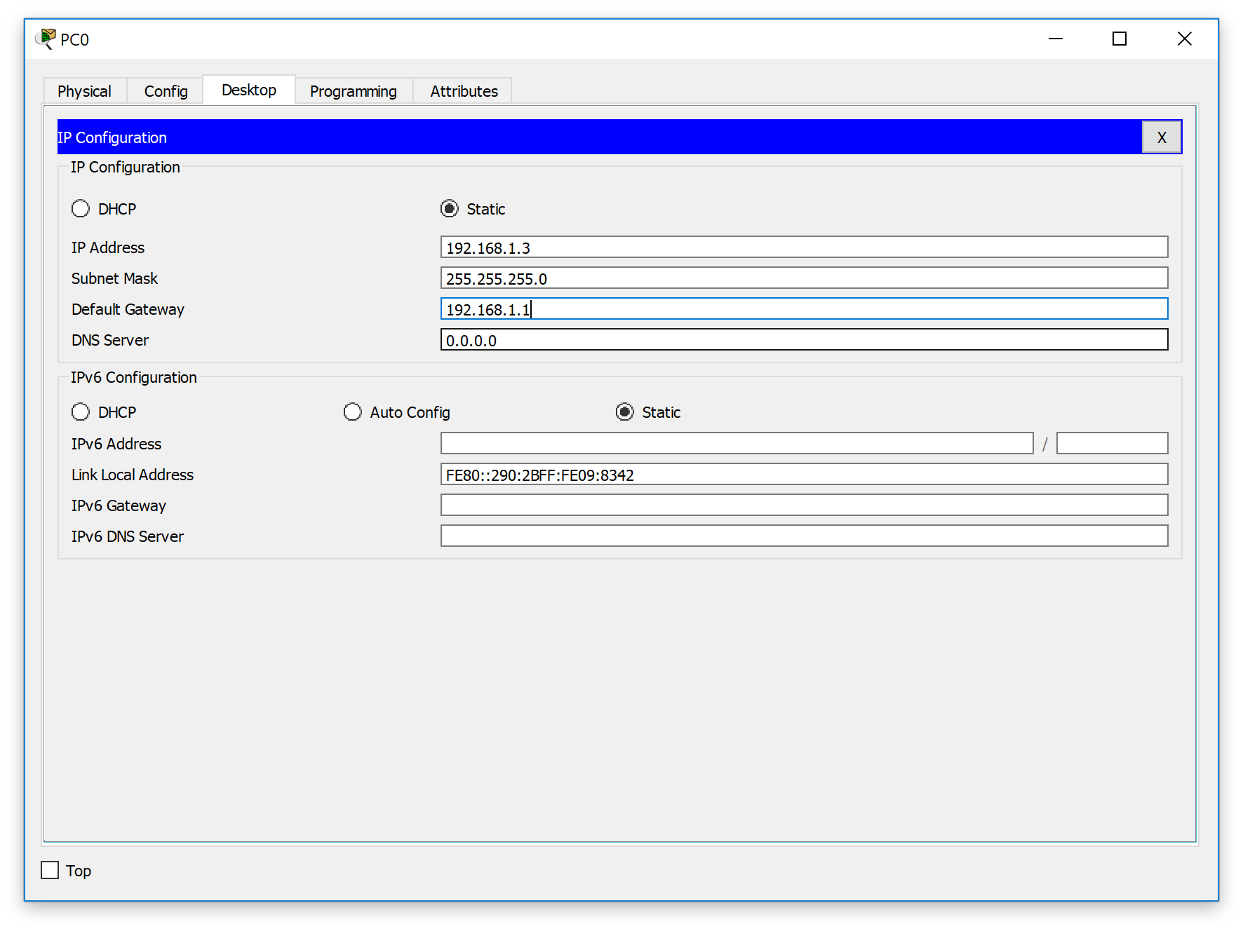

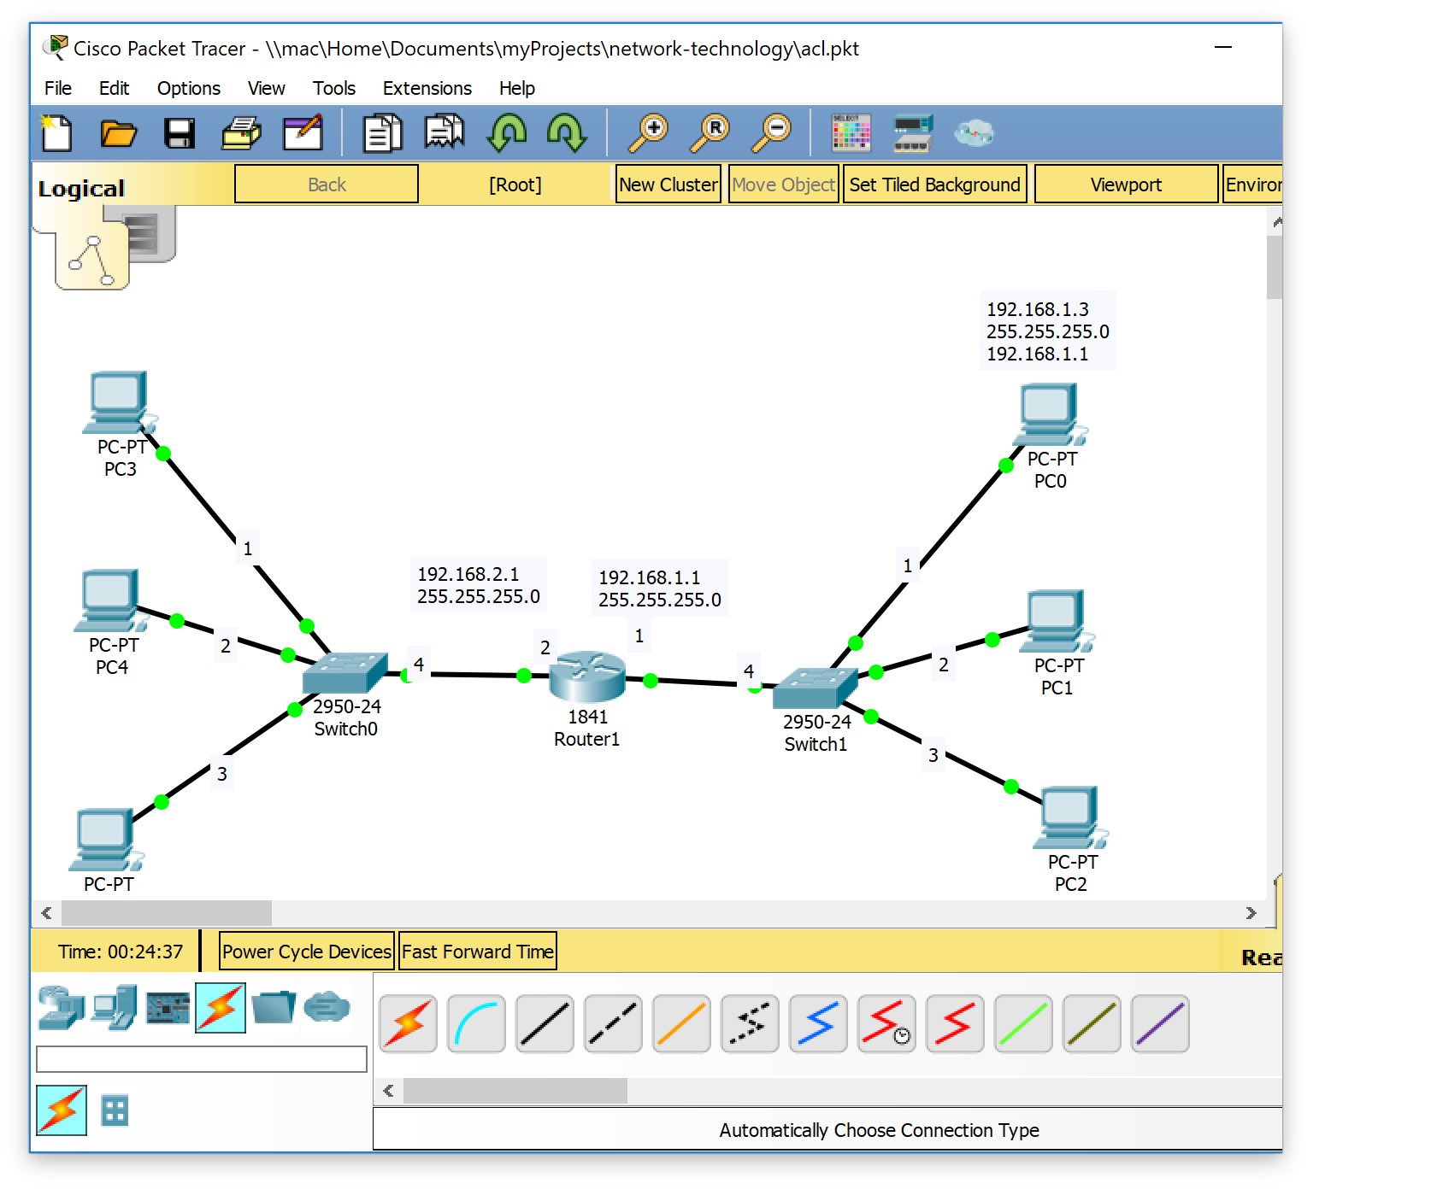

Pc3:

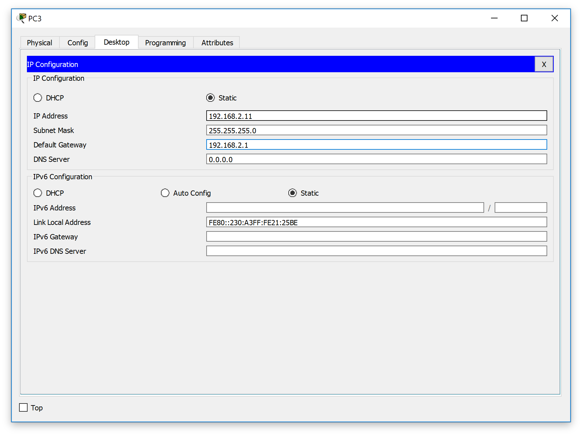

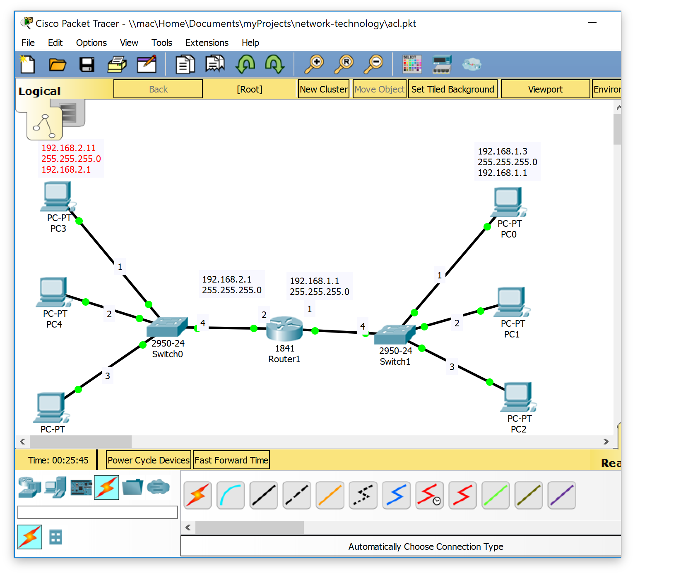

1. Thus, after applying IP addresses. We see that Packet transfer is successful.

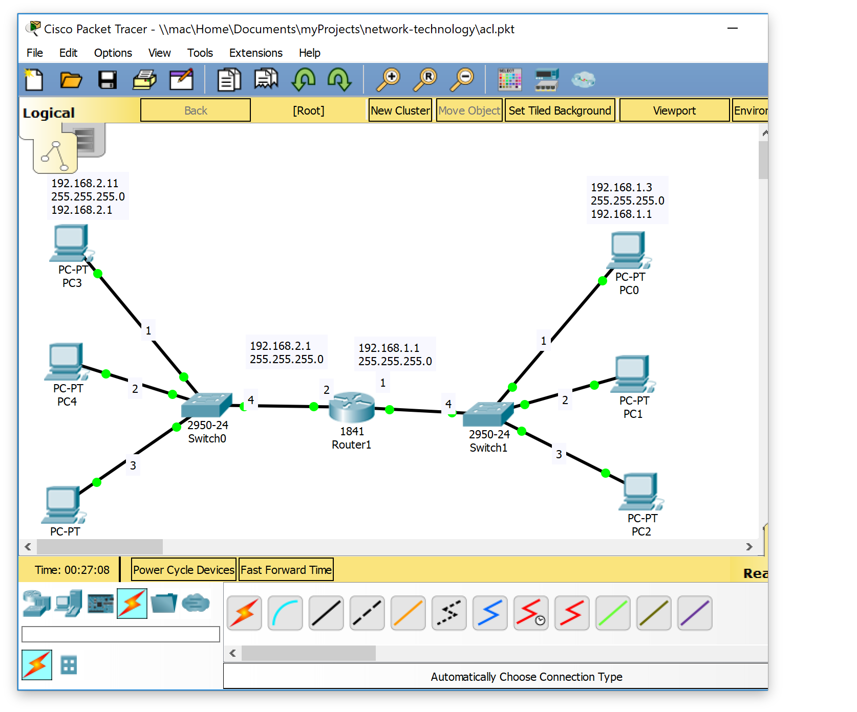

1. Let us apply ACL and permit and deny Hosts IP’s as we want. We are going to deny and permit certain hosts as follows.

DENIED PCS: PC3 PC5 PC2

PERMIT PCS: PC0 PC1 PC4

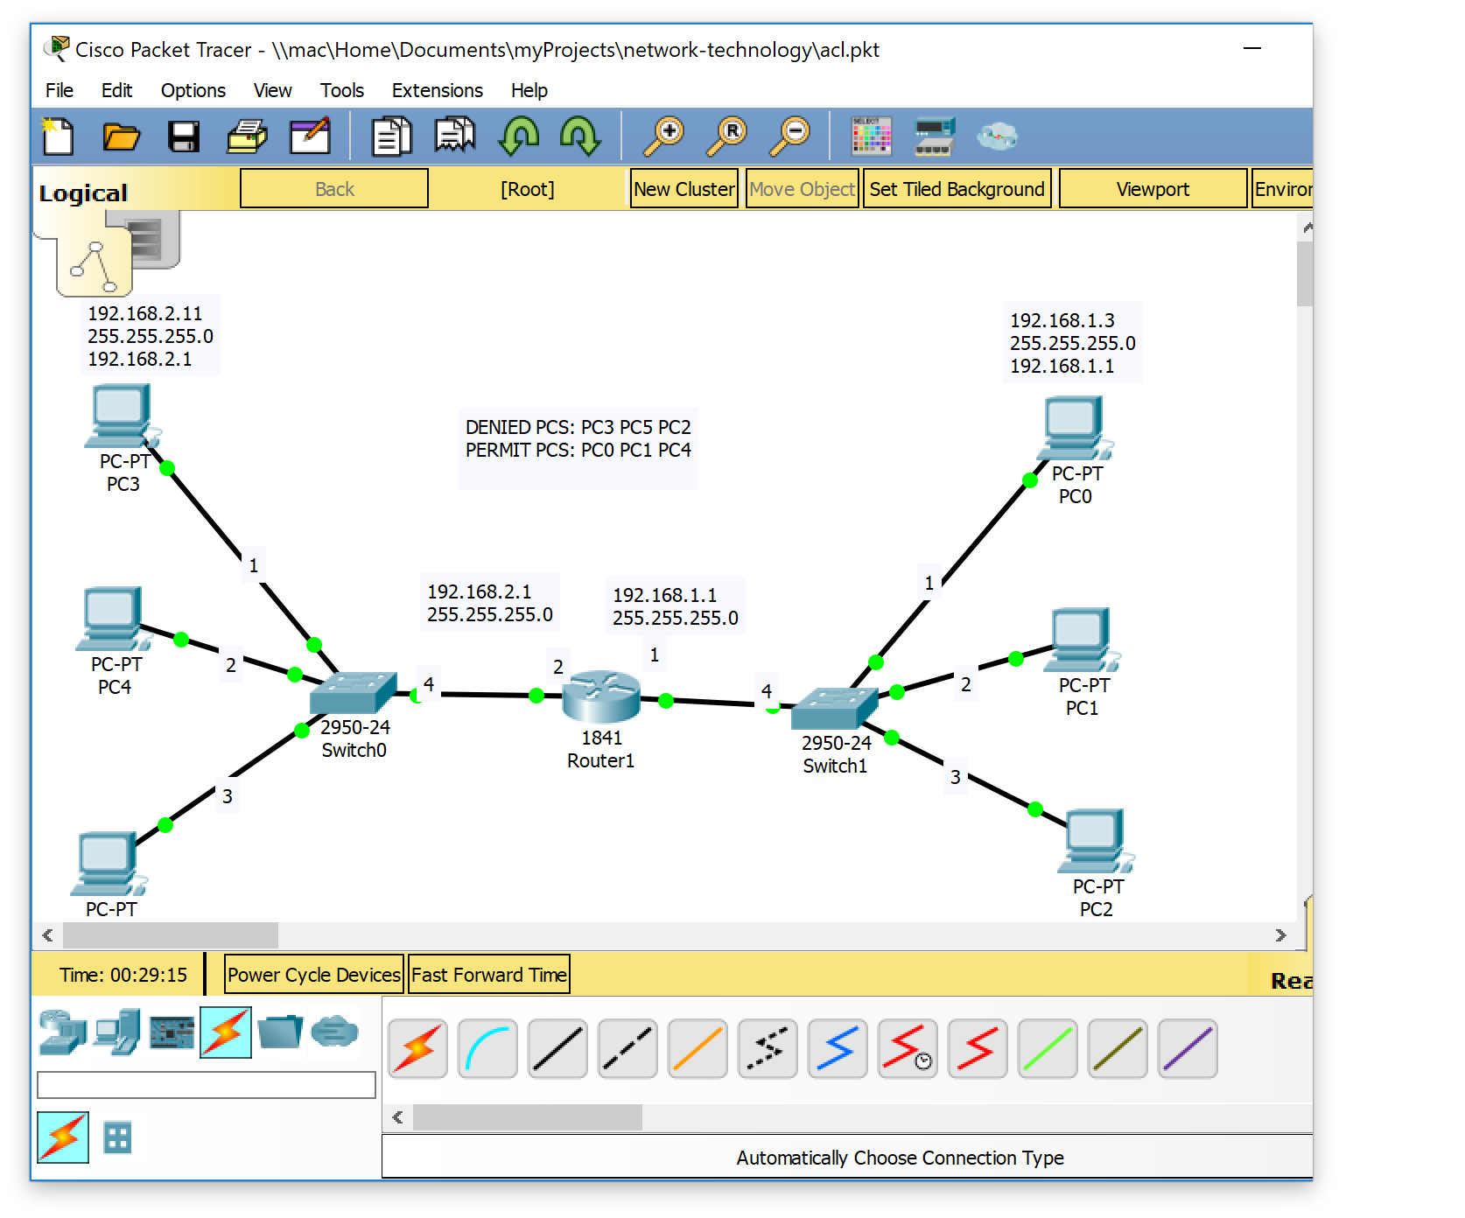

1. Let us apply ACL and permit and deny Hosts IP’s as we want.

Router(config-if)#

%LINK-5-CHANGED: Interface FastEthernet0/1, changed state to up

%LINEPROTO-5-UPDOWN: Line protocol on Interface FastEthernet0/1, changed state to up

Router(config-if)#

Router#

%SYS-5-CONFIG_I: Configured from console by console

Router#config

Configuring from terminal, memory, or network [terminal]?

Enter configuration commands, one per line. End with CNTL/Z.

Router(config)#ac

% Incomplete command.

Router(config)#access-list 1 permit host 192.168.1.3^Z

Router#

%SYS-5-CONFIG_I: Configured from console by console

Router#configure terminal

Enter configuration commands, one per line. End with CNTL/Z.

Router(config)#access-list 1 permit host 192.168.1.5

Router(config)#access-list 1 deny host 192.168.1.11

Router(config)#access-list 1 deny host 192.168.2.11

Router(config)#access-list 1 permit host 192.168.2.14

Router(config)#access-list 1 deny host 192.168.2.17

Router(config)#

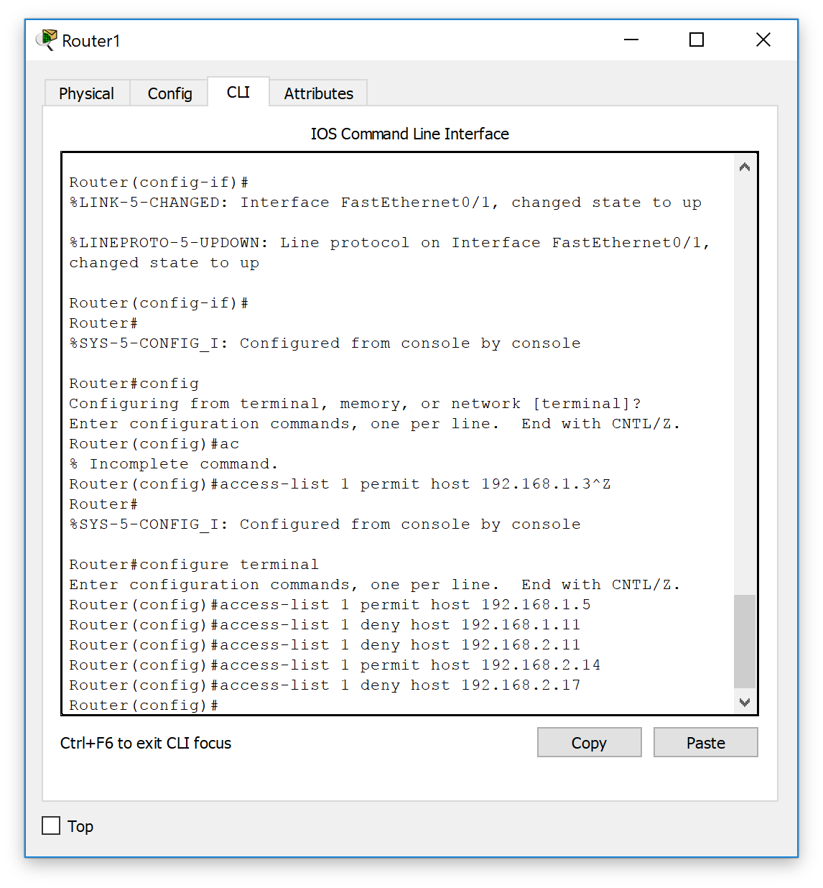

1. Then, we will have to tell the interface that which ACL to follow. ACL is uniquely identified with the number, in this

Router(config)#

Router(config)#

Router(config)#interface fa0/0

Router(config-if)#ip ac

% Incomplete command.

Router(config-if)#ip access-group 1 in

Router(config-if)#exit

Router(config)#int fa0/1

Router(config-if)#ip ac

% Incomplete command.

Router(config-if)#ip access-group 1 in

Router(config-if)#exit

Router(config)#

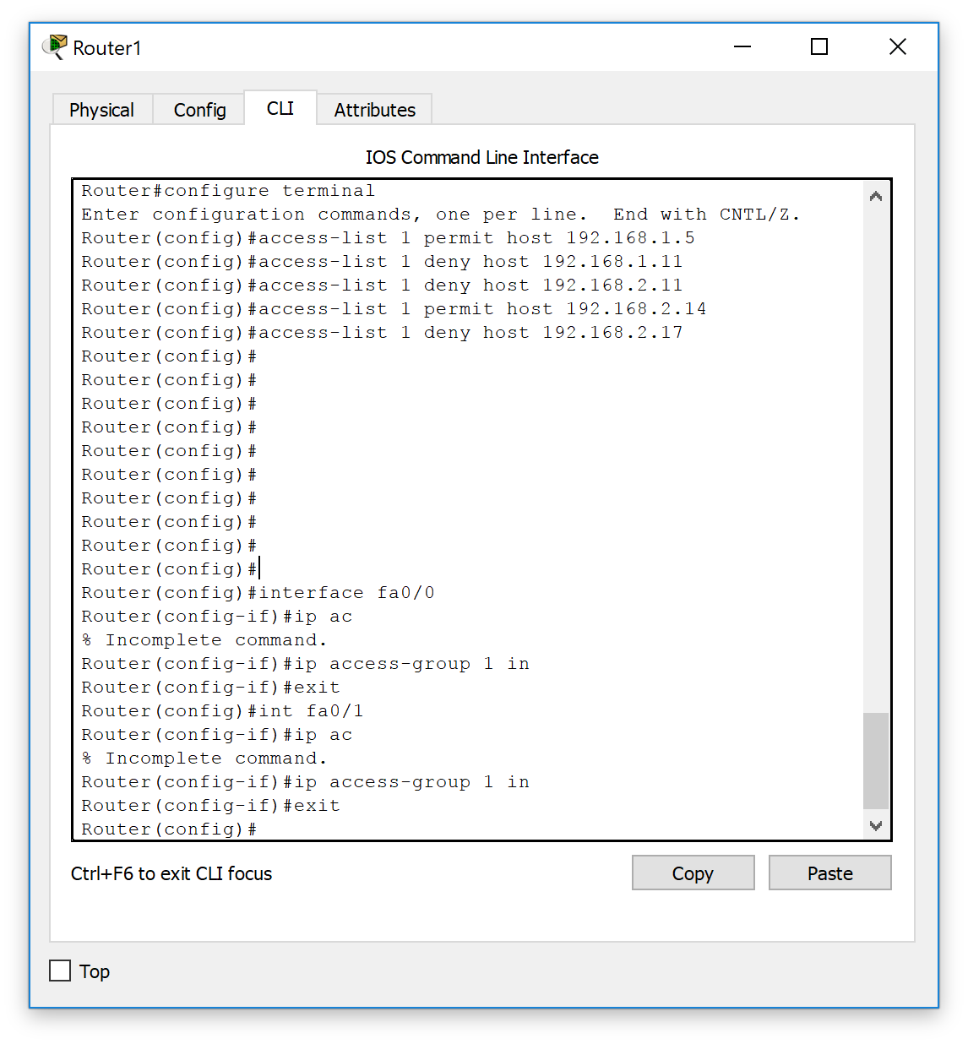

1. Now, you see that the denied will not be able to send the data while those who we permit can send packet.

